Homework 3

1. Write a program that prompts the user for a student grade average (e.g. 86.7) and outputs what the letter grade should be. Ensure that your program notifies the user if he/she enters a non-valid average (i.e. one greater than 100 or less than 0).
2. Write a program that inputs three different integers from the keyboard, then prints the sum, average, the product, the smallest, and the largest of these numbers. Use only the single-selection form of the **if** statement (don't use any form of else).

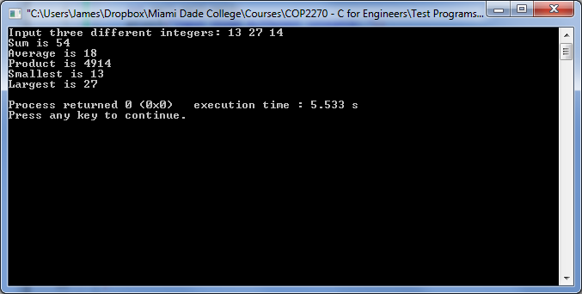

1. Write a program for a professor to calculate the average grade of a student. The program should accept as many grades as the professor wants to enter. Therefore, ask the professor for the first grade, the second grade, and so on until the professor enters a negative value. A negative value indicates that the professor is finished entering grades. Once the professor is finished, your program should output:  
     
    a) the average grade of the student  
    b) the letter grade of the student
2. Write a program that outputs the 255 characters of the ASCII table in both decimal form and it's ASCII character representation. For example, a piece of the output should look something like this:

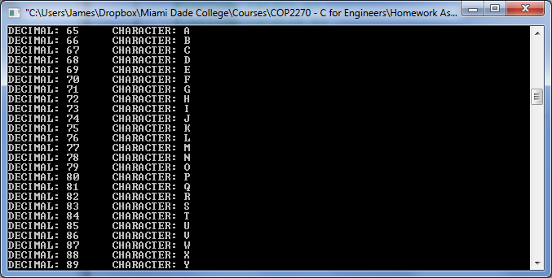

1. Write a program that will estimate the value of π from the infinite series:

$π=\frac{4}{1}-\frac{4}{3}+\frac{4}{5}-\frac{4}{7}+\frac{4}{9}-\frac{4}{11}+…$

The program should accept an integer from the user and then calculate the value of π given that many terms. For example, if the user enters 4, then the program should estimate π using the first four terms of the sequence, and output the final result:

$π=\frac{4}{1}-\frac{4}{3}+\frac{4}{5}-\frac{4}{7}≅2.895238$

* Notes: You only need to output the final floating point result. Also notice that the sequence switches from adding and subtracting each term. Also be sure your program can handle the 0 case.

Some examples:

